AHPRA Performance Report

Queensland
October-December 2016

Contents
Contents 2
Introduction 3
Registration management 4
Registrants 4
Applications for registration 5
Notifications management 6
Volume of notifications 7
Interim actions 8
Acceptance 10
Assessment 12
Investigation 14
Health assessment 16
Performance assessment 18
Panel hearing 20
Tribunal hearing 22
Statutory offence management 23
Monitoring and compliance management 25

Introduction
The Australian Health Practitioner Regulation Agency (AHPRA) works with the National Boards of 14 health professions to protect the public by regulating health practitioners efficiently and effectively in the public interest to facilitate access to safer healthcare. We believe in the importance of reporting regularly on our performance. This aims to provide clear information about what we do and how well we do it and to help us to continue to improve our services. Further information about our work is available at www.ahpra.gov.au.
What does this report cover?
This quarterly performance report summarises data for each state and territory over a three month period. It covers our main areas of activity – managing registration, managing notifications and offences against the National Law, and monitoring health practitioners and students with restrictions on their registration. Wherever possible, data for each state or territory are shown as a percentage of national activity.
The report is divided into sections. Section One covers data on registration management. Section Two covers data on notifications management. Section Three covers data on statutory offences. Section Four covers data on monitoring of practitioners with restrictions in their registration.
Data for each state and territory are reported in terms of the principal place of practice of a registered health practitioner. Each registered health practitioner must nominate a principal place of practice. This appears on the national register.
As this is a report of the performance of AHPRA and the National Boards, national activity data for notifications does not include matters managed in NSW. Notifications arising in NSW are managed by the relevant Health Professional Council and the Health Care Complaints Commission. All national notifications data in this report excludes matters managed in NSW.
From 1 July 2014, all complaints about Queensland health practitioners are made to Office of the Health Ombudsman. The Health Ombudsman takes responsibility for certain complaints, including serious complaints relating to the health, conduct and performance of health practitioners, The Health Ombudsman determines which complaints go to AHPRA and the National Boards after assessing their severity. This report only includes data about matters which have been referred by the Health Ombudsman. It does not include data about matters managed by the Office of the Health Ombudsman in Queensland.
How to use this report
The data presented in this report can be used to compare data reported within each state and territory to national activity. It can provide data for research and enable triangulation with other data sources.
AHPRA’s reporting of its activity and performance is evolving. We welcome any feedback about our performance and our reporting approach. Your contribution can help ensure the continued value of our future reports. You can provide feedback by email: reportingfeedback@ahpra.gov.au.

Registration management
Practitioners in 14 health professions are registered by AHPRA across Australia. Information about the registration status of registered health practitioners is available through the online register at http://www.ahpra.gov.au/Registration/Registers-of-Practitioners.aspx.
Registration is not conferred automatically – people must apply for registration and renew it each year. The requirements of registration vary between professions, but in general health practitioners must hold appropriate qualifications, be of good character, practise to certain standards, hold appropriate insurance and undertake continuing professional development.
Registration is conferred by the National Board of each health profession (see Table 1 for list of health professions). The National Boards are supported by AHPRA in their work to set professional standards and protect public safety.
AHPRA maintains a free online register of all registered health practitioners at www.ahpra.gov.au.
Registrants
The number of health professionals registered at the end of the latest quarter is shown in Table 1.
Table 1: Total number of registrants, by profession
Profession | ACT | NSW | NT | QLD | SA | TAS | Vic | WA | No PPP | National  (incl NSW)
Aboriginal and Torres Strait Islander Health Practitioner | 3 | 120 | 218 | 114 | 53 | 3 | 10 | 109 |  | 630
Chinese Medicine Practitioner | 67 | 1,998 | 12 | 869 | 187 | 37 | 1,312 | 261 | 129 | 4,872
Chiropractor | 66 | 1,760 | 28 | 844 | 375 | 57 | 1,358 | 618 | 171 | 5,277
Dental Practitioner | 414 | 6,795 | 153 | 4,499 | 1,835 | 375 | 5,151 | 2,618 | 623 | 22,463
Medical Practitioner | 2,017 | 33,046 | 1,191 | 21,109 | 7,773 | 2,208 | 25,985 | 10,679 | 2,836 | 106,844
Medical Radiation Practitioner | 272 | 5,276 | 107 | 3,178 | 1,188 | 322 | 3,913 | 1,360 | 260 | 15,876
Midwife | 123 | 963 | 76 | 846 | 519 | 23 | 1,183 | 380 | 151 | 4,264
Nurse | 5,467 | 95,128 | 3,762 | 68,445 | 30,509 | 8,195 | 91,235 | 34,777 | 9,675 | 347,193
Nurse and Midwife | 548 | 8,274 | 508 | 5,836 | 2,017 | 627 | 7,528 | 2,928 | 304 | 28,570
Occupational Therapist | 335 | 5,399 | 176 | 3,763 | 1,502 | 299 | 4,789 | 2,718 | 279 | 19,260
Optometrist | 73 | 1,767 | 29 | 1,068 | 295 | 94 | 1,393 | 423 | 171 | 5,313
Osteopath | 34 | 572 | 3 | 202 | 39 | 45 | 1,200 | 63 | 48 | 2,206
Pharmacist | 555 | 9,336 | 219 | 5,988 | 2,158 | 745 | 7,532 | 3,203 | 632 | 30,368
Physiotherapist | 585 | 8,717 | 174 | 5,596 | 2,363 | 477 | 7,296 | 3,584 | 1,212 | 30,004
Podiatrist | 68 | 1,288 | 21 | 822 | 431 | 107 | 1,545 | 455 | 68 | 4,805
Psychologist | 884 | 11,318 | 225 | 6,092 | 1,683 | 587 | 9,218 | 3,600 | 560 | 34,167
Total | 11,511 | 191,757 | 6,902 | 129,271 | 52,927 | 14,201 | 170,648 | 67,776 | 17,119 | 662,112

Note:
Registered health practitioners must nominate their principal place of practice in Australia, known as their PPP. This information appears in the online register. Practitioners who do not have a PPP have typically maintained their registration in Australia but are not currently in Australia.
Applications for registration
People who are becoming registered for the first time in Australia, or those who are re-registering after a period of absence, must make an application for registration and demonstrate that they meet the requirements. AHPRA is able to approve registration on behalf of the National Boards if the applications are straightforward.
If the applications are complex, they go to the appropriate National Board delegate for consideration.
Table 2 shows the number of new applications for registration finalised in the latest quarter, by profession.
There are a number of possible outcomes for a health practitioner applying for registration. While the majority of applicants have their applications approved, some applications are refused because the required standards are not met. Applicants can be registered, but in a type of registration different to that which they applied for. They can also have their application approved with conditions – for example, some practitioners will be required to practise under supervision for an initial period. In some cases, applicants withdraw their application.
Table 3 shows the outcome of new applications finalised in the latest quarter.

Table 2: Applications for registration finalised, by profession
Profession | QLD | National  (incl NSW) | % of national
Aboriginal and Torres Strait Islander Health Practitioner | 10 | 33 | 30%
Chinese Medicine Practitioner | 33 | 233 | 14%
Chiropractor | 22 | 141 | 16%
Dental Practitioner | 198 | 789 | 25%
Medical Practitioner | 1,258 | 5,772 | 22%
Medical Radiation Practitioner | 114 | 661 | 17%
Midwife | 146 | 493 | 30%
Nurse | 1,850 | 8,289 | 22%
Occupational Therapist | 267 | 1,055 | 25%
Optometrist | 33 | 103 | 32%
Osteopath | 13 | 134 | 10%
Pharmacist | 256 | 1,252 | 20%
Physiotherapist | 281 | 1,093 | 26%
Podiatrist | 39 | 154 | 25%
Psychologist | 181 | 900 | 20%
Total | 4,701 | 21,102 | 22%

Table 3: Applications for registration finalised, by outcome
Outcome | QLD | National  (incl NSW) | % of national
Register | 4,408 | 19,025 | 23%
Register with conditions | 70 | 396 | 18%
Register in a type other than applied for | 3 | 17 | 18%
Register in a type other than applied for with conditions | 6 | 40 | 15%
Refuse application | 56 | 660 | 8%
Withdrawn | 149 | 911 | 16%
Other | 9 | 53 | 17%
Total | 4,701 | 21,102 | 22%

Notifications management
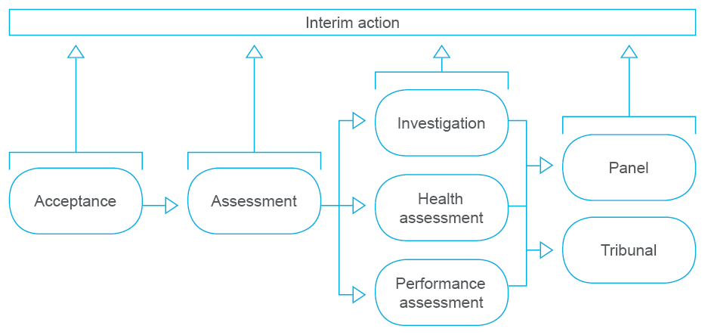
Anyone can make a complaint about a registered health practitioner’s health, performance or conduct. This is called a ‘notification’ because AHPRA and the National Boards are ‘notified’ about concerns or complaints. Queensland is an exception – it uses the term ‘complaint’. Notifications are made to AHPRA, which manages them to a certain point on behalf of the National Boards.
Once a notification has been received we need to decide whether we can accept it. In order for us to be able to accept the notification, it must relate to a health practitioner or student registered by the Board and relate to a matter that is a ground for a notification. In consultation with the health complaints entity, we will also consider whether it could also be made to a health complaints entity. A list of the health complaints entities in each state and territory is outlined later in the report in Table 10.
When accepting a notification and in every other step of our processes, we consider whether there is a serious risk to the public that requires us to take interim action to protect the public. (This is known as immediate action in the National Law).
If the notification is found to be a matter that AHPRA and National Boards could deal with, we assess it and decide what we should do with it. Assessment can lead to a range of actions, including:
- a decision to take no further action
- a decision to caution the practitioner
- a decision to accept an undertaking from the practitioner
- a decision to impose conditions on the practitioner’s registration
- a decision to pass the notification to a health complaints entity.
The assessment can also result in a decision to take further actions, such as:
- further investigation of the matter
- a health assessment
- a performance assessment
- a referral to a panel
- a referral to a tribunal.

Volume of notifications
Table 4 shows the number of notifications received in the latest quarter, by profession.
Table 5 shows the number of notifications closed in the latest quarter, by profession.

Table 4: Notifications received, by profession
Profession | QLD | National | % of national
Aboriginal and Torres Strait Islander Health Practitioner |  | 1 | 0%
Chinese Medicine Practitioner | 13 | 16 | 81%
Chiropractor | 20 | 35 | 57%
Dental Practitioner | 49 | 108 | 45%
Medical Practitioner | 326 | 852 | 38%
Medical Radiation Practitioner | 2 | 3 | 67%
Midwife | 10 | 24 | 42%
Nurse | 143 | 407 | 35%
Occupational Therapist | 3 | 7 | 43%
Optometrist | 2 | 9 | 22%
Osteopath | 1 | 5 | 20%
Pharmacist | 29 | 93 | 31%
Physiotherapist | 6 | 17 | 35%
Podiatrist | 3 | 14 | 21%
Psychologist | 23 | 79 | 29%
Yet to be coded* |  | 9 | 0%
Total | 630 | 1,679 | 38%
Note:
*This report provides a snapshot of a point in time. Details of the notification may not have been entered into the system or were not available at that time.
Table 5: Notifications closed, by profession
Profession | QLD | National | % of national
Aboriginal and Torres Strait Islander Health Practitioner |  |  | -
Chinese Medicine Practitioner | 2 | 8 | 25%
Chiropractor | 8 | 21 | 38%
Dental Practitioner | 18 | 88 | 20%
Medical Practitioner | 279 | 859 | 32%
Medical Radiation Practitioner | 1 | 9 | 11%
Midwife | 6 | 28 | 21%
Nurse | 89 | 344 | 26%
Occupational Therapist | 6 | 9 | 67%
Optometrist | 2 | 3 | 67%
Osteopath | 1 | 1 | 100%
Pharmacist | 16 | 69 | 23%
Physiotherapist | 10 | 22 | 45%
Podiatrist | 2 | 13 | 15%
Psychologist | 9 | 69 | 13%
Yet to be coded* | 1 | 5 | 20%
Total | 450 | 1,548 | 29%
Note:
* This report provides a snapshot of a point in time. Details of the notification may not have been entered into the system or were not available at that time.

At any time, there are notifications at different stages. Table 6 shows the number of open notifications at each stage of the process, as at the end of the latest quarter.
AHPRA aims to reduce the number of open notifications in a timely way. Table 7 shows the change in the number of open notifications over the latest quarter.

Table 6: Stage of open notifications at the end of the latest quarter
Stage | QLD | National | % of national
Assessment | 631 | 1,244 | 51%
Investigation | 730 | 2,285 | 32%
Health assessment | 64 | 191 | 34%
Performance assessment | 13 | 78 | 17%
Referred to a Panel | 32 | 49 | 65%
Referred to a Tribunal | 56 | 279 | 20%
Total | 1,526 | 4,126 | 37%
Table 7: Change in open notifications, by number and percentage
Status | QLD | National
Open at start of quarter | 1,354 | 3,995
Received | 630 | 1,679
Closed | 450 | 1,548
Open at end of quarter | 1,526 | 4,126
Change (no.) | 180 | 131
Change (%) | 13% | 3%
Note: Where a practitioner changes their PPP during the reporting period, this is not reported as a closure.
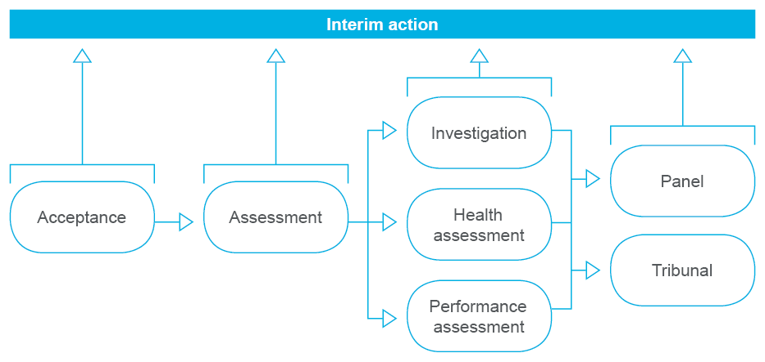
Interim actions
Notifications identify concerns about a practitioner. From the time that we first receive a notification, we evaluate the types and magnitude of risks that a practitioner might pose to the public. This has a significant influence on how we manage the notification.
If a notification discloses a serious risk to the public, National Boards have the power to take interim action (this is known as immediate action in the National Law). They follow the principles of procedural fairness by informing the health practitioner, who has the opportunity to make submissions to the National Board.
Nevertheless, these interim actions can occur with or without the cooperation of the health practitioner. They can take place at any time once the notification has been received. They do not end the matter – they protect the public while the orderly process of managing the notification continues.
As a result of an interim action, National Boards can:
- accept an undertaking by the health practitioner
- impose conditions on the health practitioner’s registration
- suspend the registration of the health practitioner pending further investigation
- accept the surrender of registration by the health practitioner.
Changes to registration as a result of interim action are published to the online register of practitioners.
Table 8 shows the outcome of interim actions taken by National Boards in the latest quarter.
Table 9 shows the median time taken for such actions. Median time is the measure used to allow international comparisons.

Table 8: Interim actions taken, by outcome
Outcome | QLD | National | % of national
Board accepts undertaking by the practitioner |  | 21 | 0%
Board imposes conditions on practitioner’s registration | 13 | 55 | 24%
Board suspends practitioner | 8 | 34 | 24%
Practitioner surrenders registration |  |  | -
Total | 21 | 110 | 19%
Table 9: Interim actions taken, by time frame
Time frame | QLD | National
Median days | 8 | 6
Note:
Median time is calculated from the time that AHPRA identifies information that suggests interim action might be necessary. It ends when the National Board decides to take interim action, having first allowed the practitioner a reasonable time to show cause as to why the proposed action is or is not necessary.

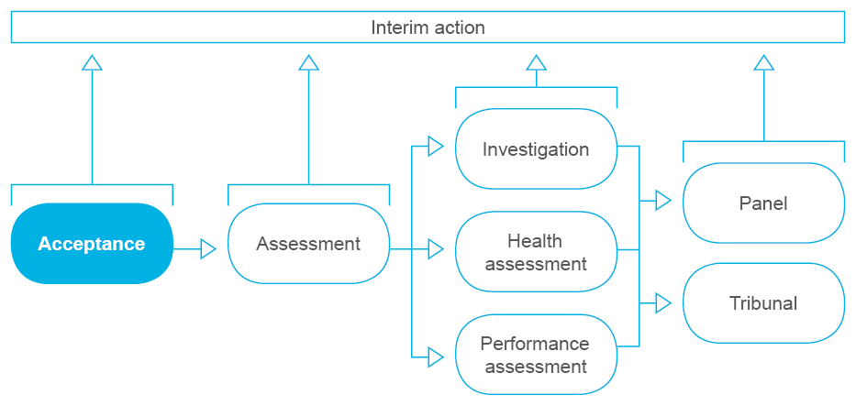
Acceptance
When accepting a notification, AHPRA appraises:
- whether or not the notification relates to a person who is a health practitioner or a student registered by the Board
- whether or not the notification relates to a matter that is a ground for notification, and
- whether or not the notification could also be made to a health complaints entity.
This reflects the requirements of the National Law, and is known as a preliminary assessment.
Nationally, during the quarter, over 98% of these preliminary assessments were completed within the 60 days required by the National Law.
A list of the health complaints entities in each state and territory is outlined below in Table 10.
If the notification isn’t about a registered health practitioner, or doesn’t relate to a ground for notification, then it can’t be accepted for management by AHPRA. Table 11 shows the number of notifications which were accepted, by profession, in the latest quarter.
Table 12 shows how many notifications were accepted for management by AHPRA and how many were not accepted in the latest quarter.

Table 10: Health complaints entities in each state and territory
State/territory | Health complaints entity
New South Wales | Health Care Complaints Commission
Australian Capital Territory | ACT Human Rights Commission
Northern Territory | Health and Community Services Complaints Commission
Queensland | Office of the Health Ombudsman
South Australia | Health and Community Services Complaints Commission
Tasmania | Health Complaints Commissioner
Victoria | Office of the Health Services Commissioner
Western Australia | Health and Disability Services Complaints Office

Table 11: Notifications considered for acceptance, by profession
 | QLD | National | % of national
Aboriginal and Torres Strait Islander Health Practitioner |  | 1 | 0%
Chinese Medicine Practitioner | 13 | 16 | 81%
Chiropractor | 17 | 35 | 49%
Dental Practitioner | 48 | 140 | 34%
Medical Practitioner | 319 | 1,026 | 31%
Medical Radiation Practitioner | 2 | 4 | 50%
Midwife | 9 | 25 | 36%
Nurse | 133 | 432 | 31%
Occupational Therapist | 3 | 8 | 38%
Optometrist | 2 | 9 | 22%
Osteopath | 1 | 8 | 13%
Pharmacist | 22 | 90 | 24%
Physiotherapist | 6 | 24 | 25%
Podiatrist | 2 | 12 | 17%
Psychologist | 19 | 92 | 21%
Yet to be coded* |  | 60 | 0%
Total | 596 | 1,982 | 30%
Table 12: Outcome of acceptance process
Outcome | QLD | National | % of national
Accepted for management by AHPRA | 611 | 1,666 | 37%
Not accepted as a notification | 6 | 322 | 2%
Total | 617 | 1,988 | 31%
Note:
Matters can include notifications as well as statutory offences.

Note:
This report provides a snapshot of a point in time. Details of the notification may not have been entered into the system or were not available at that time.

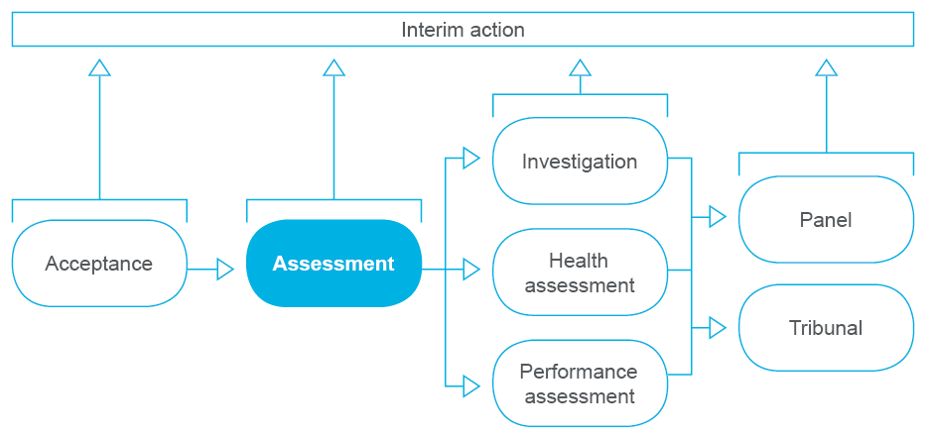
Assessment
AHPRA conducts an assessment to see if the concerns raised can be quickly and easily addressed. If not, it aims to make sure they are dealt with in the most effective way possible.
AHPRA may ask the person who made the notification for more information. It will usually send the health practitioner a copy of the notification and ask them to respond. This is not done if it would:
- prejudice an investigation
- place a person’s safety at risk, or
- place a person at risk of intimidation.
AHPRA then passes on all relevant information to the National Board so it can make a decision about what to do. National Boards have the power to:
- take no further action
- caution the practitioner
- accept an undertaking from the practitioner
- impose conditions on the practitioner’s registration
- refer the matter to another entity
- investigate the matter further
- require the practitioner to undergo a health or performance assessment
- refer the matter for hearing by a panel, or
- refer the matter for hearing by a tribunal.
Information about these potential outcomes is available at www.ahpra.gov.au/Notifications/The-notifications-process/Possible-outcomes.
We aim to complete assessments within 60 days, but the process can take longer if a National Board proposes to caution the practitioner, impose conditions on a practitioner’s registration or accept an undertaking from a practitioner. In those circumstances, a final decision cannot be made until a practitioner has an opportunity to show cause as to why the National Board should or should not proceed with its proposal.
Table 13 shows the number of assessments completed, by profession.
Table 14 shows the timeliness of the completion of the assessment.
Table 15 shows the outcomes of the assessments completed.
Table 16 shows how long assessments that were open at the end of the latest quarter had been open.

Table 13: Assessments completed, by profession
Profession | QLD | National | % of national
Aboriginal and Torres Strait Islander Health Practitioner |  |  | -
Chinese Medicine Practitioner | 3 | 9 | 33%
Chiropractor | 11 | 21 | 52%
Dental Practitioner | 21 | 88 | 24%
Medical Practitioner | 290 | 848 | 34%
Medical Radiation Practitioner | 1 | 4 | 25%
Midwife | 7 | 17 | 41%
Nurse | 70 | 324 | 22%
Occupational Therapist | 5 | 7 | 71%
Optometrist | 2 | 7 | 29%
Osteopath | 1 | 2 | 50%
Pharmacist | 14 | 94 | 15%
Physiotherapist | 5 | 18 | 28%
Podiatrist | 3 | 14 | 21%
Psychologist | 10 | 70 | 14%
Not yet coded* | 1 | 5 | 20%
Total | 444 | 1,528 | 29%
Note:
*This report provides a snapshot of a point in time. Details of the notification may not have been entered into the system or were not available at that time.
Table 14: Assessments completed, by time frame
Time frame | QLD | National | % of national
Completed in  < 60 days | 118 | 652 | 18%
Completed in > 60 days but < 90 days | 143 | 480 | 30%
Completed in  > 90 days | 89 | 188 | 47%
Completed following a show cause process | 94 | 208 | 45%
Total | 444 | 1,528 | 29%
Table 15: Assessments completed, by outcome
Outcome | QLD | National | % of national
Outcome of decision to close the notification
No further action | 206 | 710 | 29%
Board cautions practitioner | 54 | 130 | 42%
Board accepts undertaking by the practitioner | 9 | 15 | 60%
Board imposes conditions on practitioner’s registration | 21 | 45 | 47%
Assessment to be done by health complaints entity |  | 29 | 0%
Other | 2 | 13 | 15%
Outcome of decision to take the notification further
Investigation by AHPRA | 128 | 496 | 26%
Health or performance assessment | 19 | 56 | 34%
Referral to a panel | 5 | 5 | 100%
Referral to a tribunal |  |  | -
Other |  | 29 | 0%
Total | 444 | 1,528 | 29%

Table 16: Assessments open at the end of the latest quarter, by time frame
Time frame | QLD | National | % of national*
Open for  < 60 days | 419 | 851 | 49%
Open for > 60  days but < 90 days | 88 | 148 | 59%
Open for  > 90 days | 62 | 110 | 56%
Subject to a show cause process | 62 | 135 | 46%
Total | 631 | 1,244 | 51%

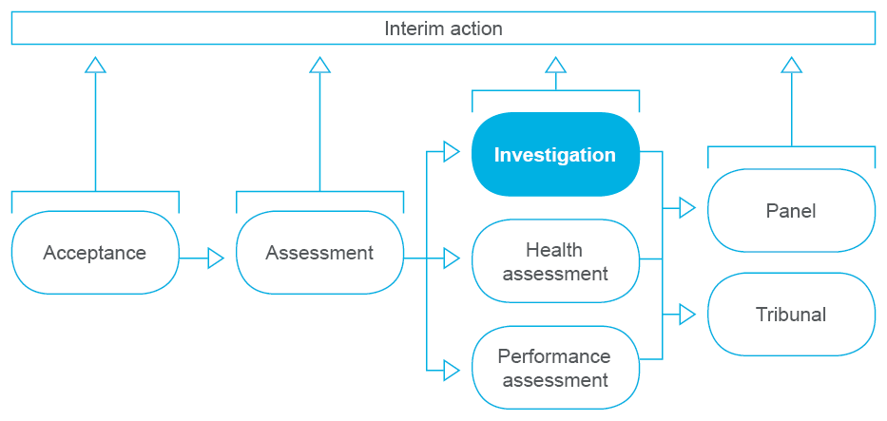
Investigation
A National Board may decide to investigate a health practitioner or student if it receives a notification or for any other reason believes that:
- the practitioner or student has, or may have, an impairment
- the way the practitioner practises is, or may be, unsatisfactory
- the practitioner’s conduct is, or may be, unsatisfactory.
Not every notification lodged is investigated, and not every investigation arises from a notification. A National Board has the power to initiate an investigation without a notification. It might do this when it becomes concerned about a practitioner through information that is in the public domain, or when information about a practitioner is revealed in an investigation about another practitioner.
A National Board may also conduct an investigation to ensure that a practitioner or student is complying with conditions imposed on their registration or an undertaking given by the practitioner or student to the Board.
After an investigation, a National Board may decide to:
- take no further action
- caution the practitioner
- accept an undertaking from the practitioner
- impose conditions on the practitioner’s registration
- refer the matter to another entity
- require the practitioner to undergo a health or performance assessment
- refer the matter for hearing by a panel, or
- refer the matter for hearing by a tribunal.
We aim to complete investigations in under six months. But sometimes gathering the information needed to complete the investigation is complex, and the investigation takes longer. All investigations are reviewed at six, nine and 12 months to make sure that the information we are gathering is necessary to resolve the investigation.
Table 17 shows the number of the investigations completed in the latest quarter, by profession.
Table 18 shows the timeliness of those completed investigations.
Table 19 shows the outcomes of the investigations completed in the latest quarter.
Table 20 shows how long investigations that were open at the end of the latest quarter had been open.

Table 17: Investigations completed, by profession
Profession | QLD | National | % of national
Aboriginal and Torres Strait Islander Health Practitioner |  | 1 | 0%
Chinese Medicine Practitioner |  | 2 | 0%
Chiropractor | 3 | 14 | 21%
Dental Practitioner | 3 | 38 | 8%
Medical Practitioner | 48 | 226 | 21%
Medical Radiation Practitioner |  | 5 | 0%
Midwife |  | 9 | 0%
Nurse | 18 | 127 | 14%
Occupational Therapist |  | 2 | 0%
Optometrist | 1 | 1 | 100%
Osteopath | 1 | 1 | 100%
Pharmacist | 3 | 20 | 15%
Physiotherapist | 3 | 9 | 33%
Podiatrist |  | 4 | 0%
Psychologist |  | 23 | 0%
Total | 80 | 482 | 17%
Note:
*This report provides a snapshot of a point in time. Details of the notification may not have been entered into the system or were not available at that time.
Table 18: Investigations completed, by time frame
Time frame | QLD | National | % of national
Completed in  < 6 months | 12 | 132 | 9%
Completed in  > 6 months but  < 12 months | 31 | 168 | 18%
Completed in  > 12 months but  < 18 months | 21 | 95 | 22%
Completed in  > 18 months | 16 | 87 | 18%
Total | 80 | 482 | 17%
Table 19: Investigations completed, by outcome
Outcome | QLD | National | % of national
Outcome of decision to close the notification
No further action | 54 | 234 | 23%
Board cautions practitioner | 1 | 73 | 1%
Board accepts undertaking by the practitioner | 4 | 15 | 27%
Board imposes conditions on practitioner’s registration | 9 | 53 | 17%
Other | 5 | 6 | 83%
Outcome of decision to take the notification further
Health or performance assessment | 3 | 40 | 8%
Referral to a panel | 3 | 10 | 30%
Referral to a tribunal | 1 | 50 | 2%
Other |  | 1 | 0%
Total | 80 | 482 | 17%

Table 20: Investigations open at the end of the latest quarter, by time frame
Time frame | QLD | National | % of national
Open for  < 6 months | 290 | 1,071 | 27%
Open for  > 6 months but  < 12 months | 288 | 769 | 37%
Open for  > 12 months but  < 18 months | 105 | 292 | 36%
Open for  > 18 months | 47 | 153 | 31%
Total | 730 | 2,285 | 32%
Note:
Interim action may be taken at any time during the notifications process, including the investigation stage, to protect the public from a practitioner who poses a serious risk to the public.

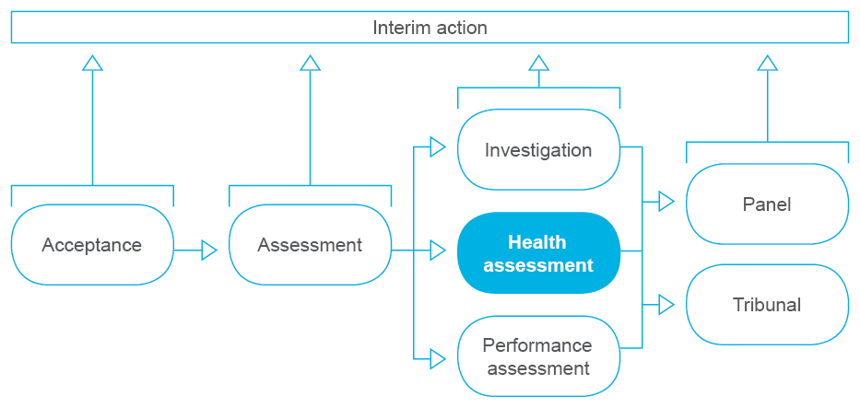
Health assessment
A National Board may require a health practitioner or student to undergo a health assessment if it believes that the practitioner or student has or may have an impairment that affects their capacity to practise.
The results of the health assessment are discussed with the health practitioner. This allows an honest discussion of any adverse findings, and ways to deal with them. It also gives the health practitioner the chance to discuss any recommendations made by the assessor.
After a health assessment, a National Board may decide to:
- take no further action
- caution the practitioner
- accept an undertaking from the practitioner
- impose conditions on the practitioner’s registration
- refer the matter to another entity
- investigate the matter further
- require the practitioner to undergo a performance assessment
- refer the matter for hearing by a panel, or
- refer the matter for hearing by a tribunal.
Table 21 shows the number of health assessments completed in the latest quarter, by profession.
Table 22 shows the timeliness of those health assessments completed.
Table 23 shows the outcomes of the health assessments completed in the latest quarter.
Table 24 shows the timeliness of those health assessments open at the end of the latest quarter.

Table 21: Health assessments completed, by profession
Profession | QLD | National | % of national
Aboriginal and Torres Strait Islander Health Practitioner |  |  | -
Chinese Medicine Practitioner |  |  | -
Chiropractor |  | 1 | 0%
Dental Practitioner |  | 1 | 0%
Medical Practitioner | 12 | 37 | 32%
Medical Radiation Practitioner |  |  | -
Midwife | 2 | 3 | 67%
Nurse | 33 | 67 | 49%
Occupational Therapist | 1 | 1 | 100%
Optometrist |  |  | -
Osteopath |  |  | -
Pharmacist | 3 | 6 | 50%
Physiotherapist | 3 | 3 | 100%
Podiatrist |  |  | -
Psychologist | 1 | 3 | 33%
Total | 55 | 122 | 45%
Note:
*This report provides a snapshot of a point in time. Details of the notification may not have been entered into the system or were not available at that time.
Table 22: Health assessments completed, by time frame
Time frame | QLD | National | % of national
Completed in  < 6 months | 22 | 59 | 37%
Completed in  > 6 months | 33 | 63 | 52%
Total | 55 | 122 | 45%
Table 23: Health assessments completed, by outcome
Outcome | QLD | National | % of national
Outcome of decision to close the notification
No further action | 15 | 44 | 34%
Board cautions practitioner | 1 | 3 | 33%
Board accepts undertaking by the practitioner | 9 | 16 | 56%
Board imposes conditions on practitioner’s registration | 28 | 42 | 67%
Practitioner surrenders registration | 1 | 1 | 100%
Other |  |  | -
Outcome of decision to take the notification further
Investigation by AHPRA |  | 12 | 0%
Referral to a panel | 1 | 3 | 33%
Referral to a tribunal |  |  | -
Other |  | 1 | 0%
Total | 55 | 122 | 45%

Table 24: Health assessments open at the end of the latest quarter, by time frame
Time frame | QLD | National | % of national
Open for  < 6 months | 35 | 111 | 32%
Open for  > 6 months | 29 | 80 | 36%
Total | 64 | 191 | 34%
Note:
Interim action may be taken at any time during the notifications process, including the health assessment stage, to protect the public from a practitioner who poses a serious risk to the public.

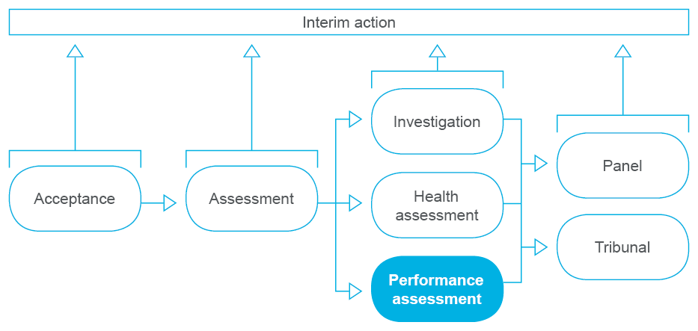
Performance assessment
A National Board may require a health practitioner to have a performance assessment if it believes that the way they practise is or may be unsatisfactory.
A performance assessment is an assessment of the knowledge, skill, judgement and care shown by a health practitioner in their work. It is carried out by one or more independent health practitioners who are not Board members.
The results of the performance assessment are discussed with the health practitioner. This allows an honest discussion of any adverse findings, and ways to deal with them. It also gives the health practitioner the chance to discuss any recommendations for upskilling, education, mentoring or supervision made by the assessor.
After a performance assessment, a National Board may decide to:
- take no further action
- caution the practitioner
- accept an undertaking from the practitioner
- impose conditions on the practitioner’s registration
- refer the matter to another entity
- investigate the matter further
- require the practitioner to undergo a health assessment
- refer the matter for hearing by a panel, or
- refer the matter for hearing by a tribunal.
Table 25 shows the number of performance assessments completed in the latest quarter, by profession.
Table 26 shows the timeliness of those performance assessments completed.
Table 27 shows the outcomes of the performance assessments completed in the latest quarter.
Table 28 shows the timeliness of those performance assessments open at the end of the latest quarter.

Table 25: Performance assessments completed, by profession
Profession | QLD | National | % of national
Aboriginal and Torres Strait Islander Health Practitioner |  |  | -
Chinese Medicine Practitioner |  |  | -
Chiropractor |  |  | -
Dental Practitioner |  |  | -
Medical Practitioner | 1 | 4 | 25%
Medical Radiation Practitioner |  |  | -
Midwife |  |  | -
Nurse |  | 6 | 0%
Occupational Therapist |  |  | -
Optometrist |  |  | -
Osteopath |  |  | -
Pharmacist |  |  | -
Physiotherapist |  |  | -
Podiatrist |  |  | -
Psychologist |  |  | -
Total | 1 | 10 | 10%

Table 26: Performance assessments completed, by time frame
Time frame | QLD | National | % of national
Completed in  < 6 months |  | 4 | 0%
Completed in  > 6 months | 1 | 6 | 17%
Total | 1 | 10 | 10%
Table 27: Performance assessments completed, by outcome
Outcome | QLD | National | % of national
Outcome of decision to close the notification
No further action | 1 | 3 | 33%
Board cautions practitioner |  |  | -
Board accepts undertaking by the practitioner |  |  | -
Board imposes conditions on practitioner’s registration |  | 5 | 0%
Other |  |  | -
Outcome of decision to take the notification further
Investigation by AHPRA |  | 2 | 0%
Referral to a panel |  |  | -
Referral to a tribunal |  |  | -
Other |  |  | -
Total | 1 | 10 | 10%

Table 28: Performance assessments open at the end of the latest quarter, by time frame
Time frame | QLD | National | % of national
Open for  < 6 months | 7 | 46 | 15%
Open for  > 6 months | 6 | 32 | 19%
Total | 13 | 78 | 17%
Note:
Interim action may be taken at any time during the notifications process, including the performance assessment stage, to protect the public from a practitioner who poses a serious risk to the public.

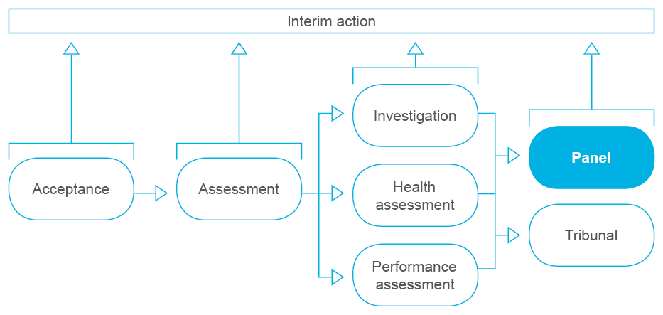
Panel hearing
A National Board can refer a matter to a health panel or a performance and professional standards panel.
A health panel is formed if a National Board believes that a health practitioner or student has, or may have, an impairment that impairs their ability to practise.
A performance and professional standards panel is formed if a National Board believes that the way a health practitioner practises is, or may be, unsatisfactory, or that the health practitioner’s professional conduct is, or may be, unsatisfactory.
The data presented below encompasses data about both health panels and performance and professional standards panels.
Table 29 shows the number of panel hearings completed in the last quarter, by profession.
Table 30 shows the timeliness of the panel hearings completed in the last quarter.
Table 31 shows the outcomes of panel hearings completed in the last quarter.

Table 29: Panel hearings completed, by profession
Profession | QLD | National | % of national
Aboriginal and Torres Strait Islander Health Practitioner |  |  | -
Chinese Medicine Practitioner |  |  | -
Chiropractor |  |  | -
Dental Practitioner |  |  | -
Medical Practitioner | 2 | 8 | 25%
Medical Radiation Practitioner |  |  | -
Midwife |  | 2 | 0%
Nurse | 3 | 7 | 43%
Occupational Therapist | 1 | 1 | 100%
Optometrist |  |  | -
Osteopath |  |  | -
Pharmacist |  |  | -
Physiotherapist |  |  | -
Podiatrist |  |  | -
Psychologist | 1 | 4 | 25%
Total | 7 | 22 | 32%

Table 30: Panel hearings completed, by time frame
Time frame | QLD | National | % of national
Completed in  < 6 months | 2 | 14 | 14%
Completed in  > 6 months | 5 | 8 | 63%
Total | 7 | 22 | 32%

Table 31: Panel hearings completed, by outcome
Outcome | QLD | National | % of national
Outcome of decision to close the notification
No further action |  | 3 | 0%
Referral to another body |  |  | -
Board cautions practitioner | 3 | 8 | 38%
Reprimand |  | 1 | 0%
Practitioner surrenders registration |  |  | -
Board suspends practitioner |  |  | -
Board accepts undertaking by the practitioner |  |  | -
Board imposes conditions on practitioner’s registration | 4 | 9 | 44%
Other |  |  | -
Outcome of decision to take the notification further
Investigation by AHPRA |  | 1 | 0%
Health or performance assessment |  |  | -
Referral to a tribunal |  |  | -
Other |  |  | -
Total | 7 | 22 | 32%

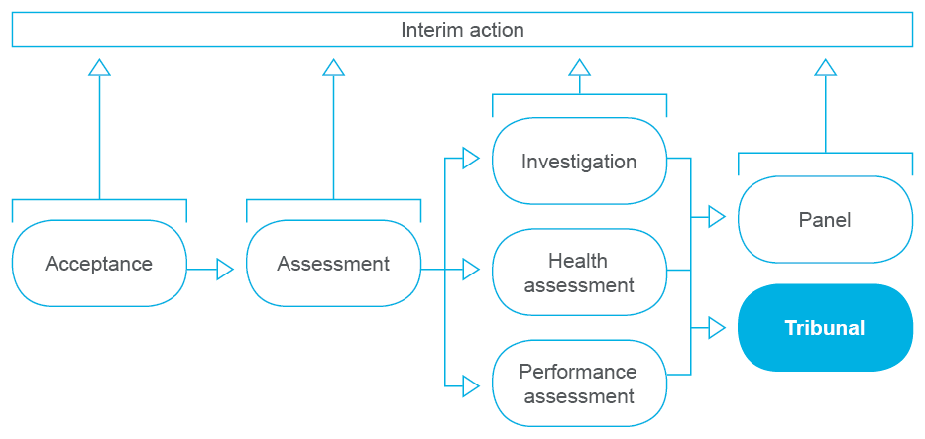
Tribunal hearing
A National Board can refer a matter to a tribunal for hearing. This happens only when the allegations involve the most serious unprofessional conduct, known as professional misconduct, and when a National Board believes suspension or cancellation of the practitioner’s registration may be warranted.
Each state and territory has its own independent tribunal as listed in Table 32.
Table 32: Tribunals in each state and territory
State/territory | Tribunal
New South Wales | Civil and Administrative Tribunal
Australian Capital Territory | Civil and Administrative Tribunal
Northern Territory | Health Professional Review Tribunal
Queensland | Civil and Administrative Tribunal
South Australia | Health Practitioners Tribunal
Tasmania | Health Practitioners Tribunal
Victoria | Civil and Administrative Tribunal
Western Australia | State Administrative Tribunal

In the future, we plan to report on performance measures about timeframes for preparing matters for submission to a tribunal, once that decision has been made by a National Board.

Statutory offence management
It is illegal for anybody who is not a registered health practitioner to pretend to be, or to carry out clinical actions as if they were, a registered health practitioner.
It is illegal for health practitioners to advertise in certain ways, and it is illegal for anyone to incite or induce a health practitioner to act in an unprofessional way.
These sorts of offences are called ‘statutory offences’. AHPRA and the National Boards take complaints about statutory offences seriously, as they are responsible for making sure that only practitioners who have the skills and qualifications to provide care are registered to practise.
Statutory offences are managed by AHPRA and Boards under a different part of the National Law to notifications. As such, statutory offences are reported separately from notifications in this report.
Table 33 shows the statutory offence matters completed in the latest quarter, by profession.
Table 34 shows the type of statutory offence matters completed during the latest quarter, by type.
Table 35 shows the outcomes of the statutory offence matters completed in the latest quarter.
Table 36 shows the number of statutory offences open at the end of the latest quarter.
Table 33: Statutory offences completed, by profession
Profession | QLD | National  (incl NSW) | % of national total
Aboriginal and Torres Strait Islander Health Practitioner |  |  | -
Chinese Medicine Practitioner | 9 | 15 | 60%
Chiropractor | 6 | 54 | 11%
Dental Practitioner | 7 | 37 | 19%
Medical Practitioner | 16 | 78 | 21%
Medical Radiation Practitioner |  | 3 | 0%
Midwife | 1 | 10 | 10%
Nurse | 2 | 28 | 7%
Occupational Therapist |  | 6 | 0%
Optometrist | 1 | 3 | 33%
Osteopath | 2 | 10 | 20%
Pharmacist |  | 5 | 0%
Physiotherapist | 6 | 602 | 1%
Podiatrist |  | 2 | 0%
Psychologist | 1 | 41 | 2%
No Profession | 2 | 46 | 4%
Total | 53 | 940 | 6%
Note:
The designation ‘No Profession’ can include persons falsely
claiming to be a registered health practitioner.

Table 34: Statutory offences completed, by type
Type | QLD | National  (incl NSW) | % of national
Falsely claiming to be a registered health practitioner | 20 | 173 | 12%
Carrying out acts that only a registered health practitioner should do |  | 3 | 0%
Breach of laws on advertising | 33 | 756 | 4%
Directing or inciting a health practitioner to act in an unprofessional way |  | 2 | 0%
Other offence |  | 6 | 0%
Total | 53 | 940 | 6%
Note:
Other offence can relate to offences under schedules 5 and 6 of the National Law.

Table 35: Statutory offences completed, by outcome
Outcome | QLD | National  (incl NSW) | % of national
Outcome where offence not prosecuted
Health practitioner complies with demand for action by Board | 14 | 120 | 12%
Referred for management as a notification | 1 | 2 | 50%
Board refers matter to another entity | 9 | 14 | 64%
No action taken | 29 | 801 | 4%
Outcome where offence prosecuted
Not guilty – acquitted |  |  | -
Guilty – no conviction, not fined |  |  | -
Guilty – no conviction, fined |  | 1 | 0%
Guilty – conviction recorded, fined |  | 2 | 0%
Total | 53 | 940 | 6%

Table 36: Open statutory offences at the end of the latest quarter
Open | QLD | National  (incl NSW) | % of national
Total | 295 | 2,046 | 14%

Monitoring and compliance management
AHPRA monitors health practitioners and students with restrictions on their registration, or whose registration has been suspended or cancelled. This helps protect the public and manage risk to patients.
Our monitoring and compliance program ensures that we know which practitioners are complying with restrictions on their registration and which are not. It also confirms that the health practitioner or student whose registration has been suspended or cancelled is not practising their profession.
Restrictions can be placed on a practitioner’s registration through a number of different mechanisms, including for example as an outcome of a notification or an application for registration.
When we monitor restrictions on a health practitioner we call it a monitoring case. Each monitoring case is assigned to one of five streams as follows:
Health: The practitioner or student is being monitored because they have a physical or mental impairment, disability, condition or disorder (including substance abuse or dependence). See the AHPRA glossary.
Performance: The practitioner is being monitored to ensure they practise safely and appropriately while demonstrated deficiencies in their knowledge, skill, judgement or care in the practise of their profession are addressed.
Conduct: The practitioner is being monitored to ensure they practise safely and appropriately following consideration of their criminal history, or they have demonstrated a lesser standard of professional conduct than expected.
Suitability/eligibility: The practitioner is being monitored because they:
- do not hold an approved or substantially equivalent qualification in the profession
- lack the required competence in the English language
- do not meet the requirements for recency of practice, or
- do not fully meet the requirements of any other approved registration standard.
Prohibited practitioner/student: the person is being monitored because they have been suspended or their registration has been cancelled.
A National Board may impose restrictions on a health practitioner with a PPP of NSW. Restrictions that are monitored in a Health, Performance or Conduct stream are transferred to the Health Professional Councils Authority in NSW for ongoing monitoring. Until the transfer of the monitoring case occurs, AHPRA is accountable for the monitoring case to ensure public safety.
Suitability/eligibility stream cases about a health practitioner with a PPP of NSW, are monitored by AHPRA.
Further information about these streams in available at http://www.ahpra.gov.au/Registration/Monitoring-and-compliance.aspx.
Table 37 shows the monitoring cases open at the end of the latest quarter, by profession.
Table 38 shows the monitoring cases open at the end of the latest quarter, by monitoring stream.
Table 39 shows the monitoring cases open at the end of the latest quarter in the jurisdiction, by profession and stream.

Table 37: Monitoring cases open at the end of the latest quarter, by profession
Profession | ACT | NSW | NT | QLD | SA | TAS | Vic | WA | No PPP | National  (incl NSW)
Aboriginal and Torres Strait Islander Health Practitioner |  | 11 | 8 | 20 | 1 |  | 3 | 39 |  | 82
Chinese Medicine Practitioner | 25 | 602 | 1 | 128 | 45 | 2 | 73 | 80 | 32 | 988
Chiropractor |  | 2 |  | 10 | 8 |  | 16 | 10 |  | 46
Dental Practitioner | 7 | 12 | 5 | 41 | 30 | 3 | 43 | 19 | 2 | 162
Medical Practitioner | 36 | 474 | 29 | 343 | 144 | 39 | 342 | 235 | 26 | 1,668
Medical Radiation Practitioner | 2 | 24 | 1 | 33 | 9 | 4 | 19 | 8 | 1 | 101
Midwife | 1 | 24 | 1 | 17 | 6 | 2 | 33 | 23 | 16 | 123
Nurse | 36 | 169 | 17 | 379 | 189 | 37 | 428 | 173 | 45 | 1,473
Occupational Therapist |  | 7 |  | 8 | 3 | 2 | 13 | 6 | 1 | 40
Optometrist | 1 | 5 |  | 5 |  | 1 | 7 | 4 |  | 23
Osteopath |  | 1 |  | 1 | 2 |  | 3 |  |  | 7
Pharmacist | 6 | 41 | 1 | 42 | 6 | 3 | 60 | 20 | 11 | 190
Physiotherapist | 2 | 11 | 2 | 17 | 6 |  | 22 | 11 |  | 71
Podiatrist |  |  |  | 3 | 2 | 1 | 8 |  | 2 | 16
Psychologist | 5 | 11 |  | 38 | 9 | 4 | 39 | 23 | 1 | 130
Total | 121 | 1,394 | 65 | 1,085 | 460 | 98 | 1109 | 651 | 137 | 5,120
Note:
1. Practitioners who do not have a PPP have typically maintained their registration in Australia but are not currently in Australia.
2. A monitoring case may be created as a result of the orders of a Tribunal. The person being monitored may not be registered and is being monitored to provide evidence as to whether or not they should be registered in the future.

Table 38: Number of monitoring cases open at
the end of the latest quarter, by monitoring stream
Profession | QLD | National  (incl NSW) | % of national total
Health | 269 | 621 | 43%
Performance | 175 | 528 | 33%
Conduct | 121 | 380 | 32%
Prohibited Practitioner / Student | 40 | 229 | 17%
Suitability / Eligibility | 480 | 3,362 | 14%
Total | 1,085 | 5,120 | 21%

Table 39: Number of QLD monitoring cases open at the end of the latest quarter, by monitoring stream and profession
Profession | Health | Performance | Conduct | Prohibited Practitioner / Student | Suitability / Eligibility | QLD Total
Aboriginal and Torres Strait Islander Health Practitioner | 1 |  |  |  | 19 | 20
Chinese Medicine Practitioner | 1 | 1 |  |  | 126 | 128
Chiropractor |  | 3 | 4 | 2 | 1 | 10
Dental Practitioner | 13 | 23 | 2 |  | 3 | 41
Medical Practitioner | 82 | 78 | 42 | 14 | 127 | 343
Medical Radiation Practitioner | 4 |  | 1 | 2 | 26 | 33
Midwife | 2 | 1 |  |  | 14 | 17
Nurse | 144 | 42 | 40 | 17 | 136 | 379
Occupational Therapist | 2 |  | 3 |  | 3 | 8
Optometrist |  | 2 |  | 1 | 2 | 5
Osteopath |  |  | 1 |  |  | 1
Pharmacist | 5 | 16 | 11 |  | 10 | 42
Physiotherapist | 6 | 2 | 2 | 1 | 6 | 17
Podiatrist | 2 |  | 1 |  |  | 3
Psychologist | 7 | 7 | 14 | 3 | 7 | 38
Total | 269 | 175 | 121 | 40 | 480 | 1,085

twitter.com/ahpra
facebook.com/ahpra.gov.au
Copyright
(C) Australian Health Practitioner Regulation Agency (‘AHPRA’). These materials are copyright. Apart from any fair dealing for the purpose of private study, research, criticism or review, as permitted under the Copyright Act, no part may be reproduced without written permission.
AHPRA provides these materials for information only. Use at your own risk.

South Australia
Level 11
80 Grenfell St
Adelaide SA 5000

Tasmania
Level 5
99 Bathurst St
Hobart TAS 7000

Victoria
Level 8
111 Bourke St
Melbourne VIC 3000

Western Australia
Level 1
541 Hay St
Subiaco WA 6008

Australian Capital Territory
Level 2
103-105 Northbourne Ave
Turner ACT 2612

New South Wales
Level 51
680 George St
Sydney NSW 2000

Northern Territory
Level 5
22 Harry Chan Ave
Darwin NT 0800

Queensland
Level 18
179 Turbot St
Brisbane QLD 4000

Australian Health Practitioner Regulation Agency
GPO Box 9958 in your capital city
www.ahpra.gov.au

The Health Practitioner Regulation National Law, as in force in each state and territory.

