**Health Professions**

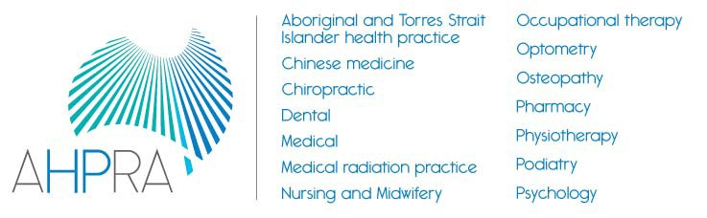

Accreditation Councils’ *Forum*

**Joint meeting of National Boards, Accreditation Authorities and AHPRA to discuss the National Registration and Accreditation Scheme**

The National Registration and Accreditation Scheme (the National Scheme) is a multi-profession scheme to regulate fourteen health professions in the public interest. The Health Practitioner Regulation National Law, as in force in each state and territory, establishes fourteen National Boards and the Australian Health Practitioner Regulation Agency. As part of the National Scheme, there is an Accreditation Authority for each profession, either an external accreditation body (11) or a committee established by the National Board (3). The Accreditation Authorities, National Boards and AHPRA all apply the objectives and guiding principles of the National Law in their work, with protection of the public as the core objective.

The National Scheme places the accreditation of programs of study in 14 regulated health professions in a legal framework which defines accreditation functions as well as the responsibilities of Accreditation Authorities and the National Boards for each profession.

Under the National Scheme, accreditation is the key quality assurance mechanism for programs of study leading to registration. It ensures that graduates completing approved programs of study in one of the regulated health professions have the knowledge, skills and professional attributes to practise the relevant profession in Australia.

As part of ongoing collaboration between National Boards, Accreditation Authorities and AHPRA, a joint meeting is held every year to discuss how to build the effectiveness of the National Scheme, particularly in the area of accreditation.

The 2015 joint meeting was held in Melbourne on 1 December 2015. The focus of this meeting was to discuss innovation and improvements in accreditation since the National Scheme began in 2010, reflect on the learnings from the recent independent review of the National Scheme and prepare for the further review of accreditation functions proposed by Health Ministers.

The meeting considered examples of innovation in the delivery of accreditation functions. There was a strong focus on cross-profession collaboration in areas such as accreditation standard development, harmonisation of accreditation processes and the development of prescribing standards. The meeting also discussed the issue of developing more outcome-focused standards. In future, the Health Professions Accreditation Councils’ Forum (a coalition of the eleven independent accreditation councils for regulated professions) will publish a list of accreditation innovations on its website, so that this information is available publicly.

The meeting also discussed areas where the operations of the accreditation functions under the National Scheme can be improved and better communicated, including:

* facilitating a better understanding of the accountability framework which applies to all accreditation authorities
* enhancing, and better communicating, the significant commonality in accreditation processes and standards across the accreditation authorities, and
* defining and explaining the costs of accreditation.

The National Boards, Accreditation Authorities and AHPRA agreed that further joint work over the next twelve months is essential, to continue to make the National Scheme as effective as possible and to address areas where improvements are necessary.