Submission to the Medical Board Consultation on Good Medical Practice
by Dr David Phillips – CONTENT REDACTED
1 August 2018
The Medical Board of Australia released a draft revised code of conduct, Good medical practice: A code of conduct for doctors in Australia on 13 June 2018 and has invited feedback by 3 August 2018.
The current code, Good medical practice: A code of conduct for doctors in Australia, was published by the Medical Board in March 2014.
This submission addresses some of the proposed changes that are of particular concern.
3.4 Decisions about access to medical care
The current code is section 2.4.
The current subsection 2.4.3 reads: “Upholding your duty to your patient and not discriminating on medically irrelevant grounds, including race, religion, sex, disability or other grounds, as described in anti-discrimination legislation.” The proposed new subsection 3.4.3 would add the protected attributes “gender identity” and “sexual orientation”.
Firstly, the current list of protected attributes is already potentially problematic. Race, for example, can be medically relevant due to the significant number of race-related genetic disorders, including cystic fibrosis, sickle-cell anaemia, lactose intolerance. Religion can also be medically relevant, for example, when penile subincision or female genital mutilation performed for religious reasons result in significant medical problems., Sex can be highly relevant medically because some diseases or conditions occur only in men or only in women.
Secondly, the proposed addition of “gender identity” and “sexual orientation” are even more problematic because they are the subject of highly contentious and ongoing debate. No doctor should be forced to conform to an ideology that he or she considers to be contrary to good medical practice.
Paediatrics Professor Dr John Whitehall, from Western Sydney University, strongly dissents from the current consensus for medical intervention in childhood gender dysphoria. The procedure known as the Dutch Protocol involves giving the child puberty-blocking hormones, then cross-sex hormones – with unknown consequences for brain development.
Professor John Whitehall has questioned the willingness of the doctors and the courts to allow young children to alter their gender via medical intervention.
Whitehall advises instead a compassionate “watch and wait” approach which usually sees dysphoria disappear through puberty. The child often turns out simply to be homosexual.
Dr Whitehall points out that the medical consensus also once was for frontal lobotomies, performed with just as little scientific evidence.
Eugenics was the medical consensus mid-last century, when mentally ill and disabled people were sterilised to eradicate their genes.
“If doctors had spoken out more vociferously, the eugenics program in America may not have been so widespread,” he says.
Through history, dissident doctors opposed to the medical consensus have advanced science.
In the 19th Century, Hungarian doctor Ignaz Semmelweis hypothesised that new mothers were dying of childbed fever in his Vienna hospital because doctors weren’t washing their hands. He asked them to clean their hands with chlorine before attending childbirths and the rate of childbed fever plummeted.
But the doctors didn’t like being blamed so they sacked Semmelweis and he ended up in a mental asylum. Today we know he was right. Hand-washing prevents the spread of disease.
You don’t have to agree with dissident doctors, but no-one has the right to silence them under threat of serious legal sanctions.
The inclusion of sexual orientation as a protected attribute is equally problematic. The practice of so-called “gay conversion therapy” is hotly debated. A person who is experiencing unwanted same-sex attraction should be able to receive appropriate help from a doctor or counsellor.
Scientific literature shows that sexual orientation is not fixed but fluid. People change between homosexual and heterosexual orientation to a surprising degree in both directions, but a far greater proportion of homosexuals become heterosexual than heterosexuals become homosexual. Some of the change is assisted by therapists, but in most cases it appears to be circumstantial. Life itself can bring along the factors that make the difference.
Several researchers have reported major spontaneous changes in sexual attraction and behaviour over time. For example, a study of Dutch adult males found that, of those who had experienced same-sex attraction at some stage of their lives, about half reported those feelings disappeared later in life. And a New Zealand cohort study found that one half of females and one third of males with occasional same-sex attraction at 21 years had only opposite-sex attraction as 26-year-olds.
Sexual attraction is particularly unstable in adolescents. US longitudinal research on adolescent health, using large scale surveys of 16, 17 and 22-year-olds, revealed major changes in romantic attraction and sexual behaviour between these ages. Of the boys who identified at 16 years as same-sex attracted, 72% were opposite-sex attracted by the age of 22 years – they had “discovered” girls. And of the same-sex attracted girls at 16 years, 55% were opposite-sex attracted by 22.
If the US results on changes between the ages of 16 and 22 years are combined with the New Zealand changes between 21 and 26 years, some 80% of same-sex attracted boys and girls could become opposite-sex attracted as adults.
Given the diversity of opinions on the fluidity of sexual orientation, medical practitioners should have the freedom to advise patients in accordance with their own medical judgement.
Recommendation: The current wording of subsection 2.4.3 should be retained in the proposed subsection 3.4.3.
4.8 Culturally safe and respectful practice
The current section 3.7 has been almost completely re-written to form the proposed section 4.8. The extent of the changes is shown in the following comparison:
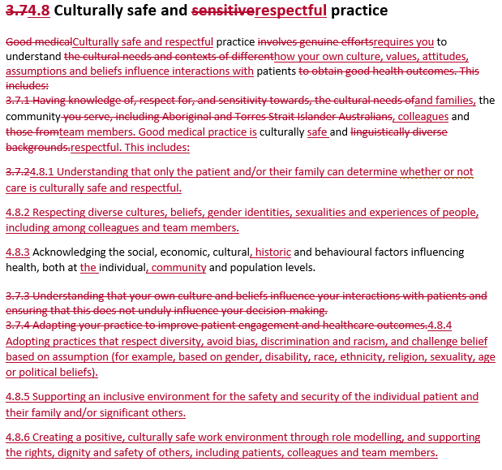
The tone of the preamble is totally changed – from courteous to belligerent. The current preamble says: “Good medical practice involves genuine efforts to understand …” whereas the proposed replacement demands: “Culturally safe and respectful practice requires you to understand …” (emphasis added).
The title of the section replaces “sensitive” with “respectful” and the text of the section involves heavy use of “respect” or similar. The implications of this change are considerable. “Sensitive” conveys meanings such as “thoughtful”, “sympathetic”, “understanding”, “perceptive”, “considerate” or “caring” which are appropriate in medical practice. In contrast, “respectful” implies “deferential”, “reverential”, “humble” or “dutiful” and describes the attitude of a servant in relation to a master.
Imposing this proposed section on the medical profession could place doctors in an impossible position of having to accept the beliefs of patients that are dangerous to their health and contrary to good medical practice. The proposed requirement in subsection 4.8.2 to respect “diverse cultures, beliefs, gender identities, sexualities and experiences” could prevent the practice of evidence-based medical practice and require the acceptance of myths and delusions.
The wording of subsection 4.8.4 includes ideologically loaded terms including “diversity”, “discrimination”, “racism” and “challenge belief”, which are highly inappropriate in a code supposedly about good medical practice. The inappropriateness of listing as protected such attributes as “disability, race, ethnicity, religion, sexuality, age or political beliefs” is discussed earlier in this submission.
Recommendation: Since the proposed wording of section 4.8 is completely inappropriate, the current wording of section 3.7 should be retained.

Medical Board of Australia, “Public consultation on draft revised code of conduct, Good medical practice: A code of conduct for doctors in Australia”, http://www.medicalboard.gov.au/News/Current-Consultations.aspx
Medical Board of Australia, Good medical practice: A code of conduct for doctors in Australia, March 2014, http://www.medicalboard.gov.au/Codes-Guidelines-Policies/Code-of-conduct.aspx
“Race and health”, Wikipedia, https://en.wikipedia.org/wiki/Race_and_health#Race_and_disease
“Penile subincision”, Wikipedia, https://en.wikipedia.org/wiki/Penile_subincision
“Female genital mutilation”, Wikipedia, https://en.wikipedia.org/wiki/Female_genital_mutilation
“Sex differences in medicine”, Wikipedia, https://en.wikipedia.org/wiki/Sex_differences_in_medicine
Miranda Devine, “The Medical Board has become the censorship board”, The Daily Telegraph, 28 July 2018, https://www.dailytelegraph.com.au/rendezview/the-medical-board-has-become-the-censorship-board/news-story/e971dfbfdc41654033bc9c2d2a57be24
Paul Karp, “Michael McCormack says he has 'no view' on gay conversion therapy”, The Guardian, 19 April 2018, https://www.theguardian.com/australia-news/2018/apr/19/michael-mccormack-says-he-has-no-view-on-gay-conversion-therapy
Sandfort, T G M, 1997, “Sampling male homosexuality”, in J. Bancroft (Ed.), Researching sexual behavior: Methodological issues, pp 261–275 (Bloomington, IN: Indiana University Press).
Dickson, N, Paul, C & Herbison, P, 2003, “Same-sex attraction in a birth cohort: Prevalence and persistence in early adulthood”, Social Science & Medicine, Vol 56, pp 1607–1615.
Savin-Williams, Ritch C and Geoffrey L Ream, 2007, “Prevalence and stability of sexual orientation components during adolescence and young adulthood.” Archives of Sexual Behavior, Vol 36, Issue 3, pp 385-394.

