|  |  |
| --- | --- |
|  | Information for applicants: How to provide evidence of your English language skills |

National Boards develop registration standards which outline requirements for demonstrating the English language skills necessary for applicants to be suitable for registration in their relevant health profession.[1]

There are essentially three English language skills registration standards (ELSR standards). These are:

1. the common standard, which applies to 12 professions (Chinese medicine, chiropractic, dental, medical, medical radiation practice, occupational therapy, optometry, osteopathy, pharmacy, physiotherapy, podiatry and psychology) (with a small number of additional words for dental and two additional tests for medical)
2. the nursing and midwifery standard, and
3. the Aboriginal and Torres Strait Islander health practice standard.

This document explains how to provide evidence for the common ELSR standard.

Background

To practise safely in Australia, registered health practitioners must have strong English language skills. This includes being able to communicate effectively with patients and their relatives, collaborate with other health care professionals and keep clear and accurate health records. The English language standards set by the National Boards help to ensure that everyone who registers as a health practitioner in Australia possesses these skills, regardless of their language background or visa status.

The common ELSR standard offers four pathways for applicants to demonstrate that they have the necessary English language skills to meet the standard and safely practice as registered health practitioners in Australia.

This guide sets out the evidence requirements for each of the four pathways.

It is important that you provide accurate information. You will need to sign a declaration on the application form that the information you provide is true and correct, including the information you provide about your English language skills. A false statement may be grounds for the Board to refuse registration or take further action if necessary.

Evidence requirements for each pathway

**1. Primary language pathway**

English is your **primary language** and you have undertaken and satisfactorily completed:

1. all of your **primary** and **secondary education** which was taught and assessed solely in English in a recognised country, and
2. **tertiary qualifications** in the relevant professional discipline, which you are relying on to support your eligibility for registration under the National Law, which were taught and assessed solely in English.

If you are using this pathway, English must be your primary language. This means that English must be the language you primarily use for reading, writing, listening and speaking and the language you know best and are most comfortable with.

For part (a) you will need to complete the table in the application form listing full details of your primary and secondary education. A sample table is attached.

For part (b), if your qualification is not from a **Board approved program of study**, you must provide confirmation that the course was taught and assessed solely in English by providing a certified copy of your transcript.

If your transcript does not show that the program of study was taught and assessed solely in English, including the clinical aspects of the program involving direct communication with patients, relatives and other healthcare professionals, you will also need to arrange for a letter to be sent directly to AHPRA by your education provider, using the template form (which will be published when available).

If your qualification is from a **Board approved program of study**, you do not need to provide additional evidence under part (b) unless requested by AHPRA.

**2. Combined secondary and tertiary education pathway**

You have a combination of secondary education and tertiary qualifications, where you have undertaken and satisfactorily completed:

* 1. at least two years of your secondary education which was taught and assessed solely in English in a recognised country, and
  2. tertiary qualifications in the relevant professional discipline, which you are relying on to support your eligibility for registration under the National Law, which were taught and assessed solely in English in a recognised country.

If you are using this pathway, you will need to do the following.

For part (a), complete the table in the application form listing details of your relevant secondary education. A sample table is attached.

For part (b), if your qualification is not from a **Board approved program of study**, you must provide confirmation that the course was taught and assessed solely in English by providing a certified copy of your transcript.

If the transcript does not show that the program of study was taught and assessed solely in English, including the clinical aspects of the program involving direct communication with patients, relatives and other healthcare professionals, you will also need to arrange for a letter to be sent directly to AHPRA by your education provider, using the template form (which will be published when available).

**3. Extended education pathway**

You have undertaken and satisfactorily completed at least six years’ (**full-time equivalent**) **continuous education** taught and assessed solely in English, in any of the recognised countries, which includes tertiary qualifications in the relevant professional discipline which you are relying on to support your eligibility for registration under the National Law*.*

If you are using this pathway, you will need to:

1. complete the table in the application form listing details of the education you are relying on , and
2. provide a certified copy of your transcript(s).

If the transcript does not show that the program of study was taught and assessed solely in English, including the clinical aspects of the program involving direct communication with patients, relatives and other healthcare professionals, you will also need to arrange for a letter to be sent directly to AHPRA by your education provider, using the template form (which will be published when available).

A sample table is attached.

**4. English language test pathway**

You achieve the required minimum scores in one of the following English language tests and meet the requirements for**test results**specified in this standard:

[...]

The following requirements apply to the English language test results:

1.Test results will be accepted if they were obtained:

1.1 within the two years before the date you lodge your application for registration

**OR**

1.2 more than two yearsbefore the date you lodge your application for registration if, in the period since the test results were obtained, you:

* 1. have been in continuous employment as a registered health practitioner in the <xx> profession (which commenced within 12 months of the date of the test) in one of the recognised countries where English was the primary language of practice, and
  2. lodge your application for registration within 12 months of finishing your last period of employment

**OR**

1.3 more than two years before the date you lodge your application for registration if, in the period since the test result was obtained, you:

1. have been continuously enrolled in a **Board approved program of study** (which commenced within 12 months of the date of the test) and undertook subjects in each semester, with no break from study apart from the education provider’s scheduled holidays, and
2. lodge your application for registration within 12 months of completing the **Board approved program of study**.
3. For the purposes of calculating time, if an applicant relies on **test results** from two sittings, time begins to run from the date of the earlier sitting.

If you are using this pathway, you should provide the following:

1. For test results from the last two years, the name of the test provider and a copy of your results which includes the number required for AHPRA staff to verify your results.
2. For medicine only, if you are relying on:
3. the **PLAB test**, you should provide a certified copy of your test results
4. The **NZREX test**, you should provide a certified copy of your test results
5. For test results more than two years old:
   1. when you are relying on a period of employment to extend the validity of your test result, a certified copy of test results plus your CV and:

* a letter from employer/s confirming continuous employment as a registered health practitioner in a recognised country where English is the primary language of practice over the last two years using the template form (which will be published when available), or
* a letter from a professional referee confirming continuous employment as a registered health practitioner in a recognised country over the last two years using the template form (which will be published when available).
  1. when you are relying on continuous enrolment in Board approved program of study to extend the validity period of test results, a certified copy of test results plus a transcript that shows that you have been enrolled continuously in a Board approved program of study and that you:
* commenced this study within 12 months of sitting the test, and
* completed your study no longer than 12 months before lodging your application.

**Glossary**

**Board approved program of study** means an accredited program of study approved by the relevant National Board under section 49(1) of the National Law and published on the list of approved programs of study on the Board’s website.

**Continuous employment** means working the equivalent of at least 26 weeks per year.

**Continuous education** meanseducation over consecutive calendar years without a break from study apart from the educational institution’s scheduled holidays.

**Full-time equivalent** means the normal course load that a student would need to take in order to complete a course in the minimum time (not including accelerated or fast-track courses). For example, a full-time load for a four year undergraduate degree would be the normal course load for a student who would expect to complete that degree in four years. This is set by the relevant educational institution.

**National Law** means the Health Practitioner Regulation National Law, as in force in each state and territory.

**NZREX** means New Zealand Registration Examination administered by the New Zealand Medical Council.

**PLAB** test means the test administered by the Professional and Linguistic Assessments Board of the General Medical Council of the United Kingdom.

**Primary education** means Australian school years one (1) through to six (6) inclusive (or equivalent).

**Primary language** means the language primarily used for reading, writing, listening, and speaking and the language known best and most comfortable.

**Recognised countries** means the following countries: Australia, Canada, New Zealand, Republic of Ireland, South Africa, United Kingdom, United States.

**Secondary education** meansAustralian school years seven (7) through to twelve (12) inclusive (or equivalent), even when year seven is classified as primary education in a particular state or territory.

**Tertiary qualifications** means qualifications obtained from a university, either as an undergraduate or a graduate.

**Vocational education** means education taught and assessed in English in Australia where:

1. the level of the vocational education was at the Australian Qualifications Framework Level 3 or Certificate III or higher (<http://www.aqf.edu.au/aqf/in-detail/aqf-levels/>)
2. the vocational education provided was undertaken primarily face to face and requires students to use English language speaking, writing, reading and listening skills, and
3. no more than two years (full time equivalent) of the vocational education was unrelated to health care or health service provision.

We may ask you for evidence to show that your vocational education meets these requirements.

Sample education tables – common ELS registration standard

##### Combined secondary and tertiary education pathway

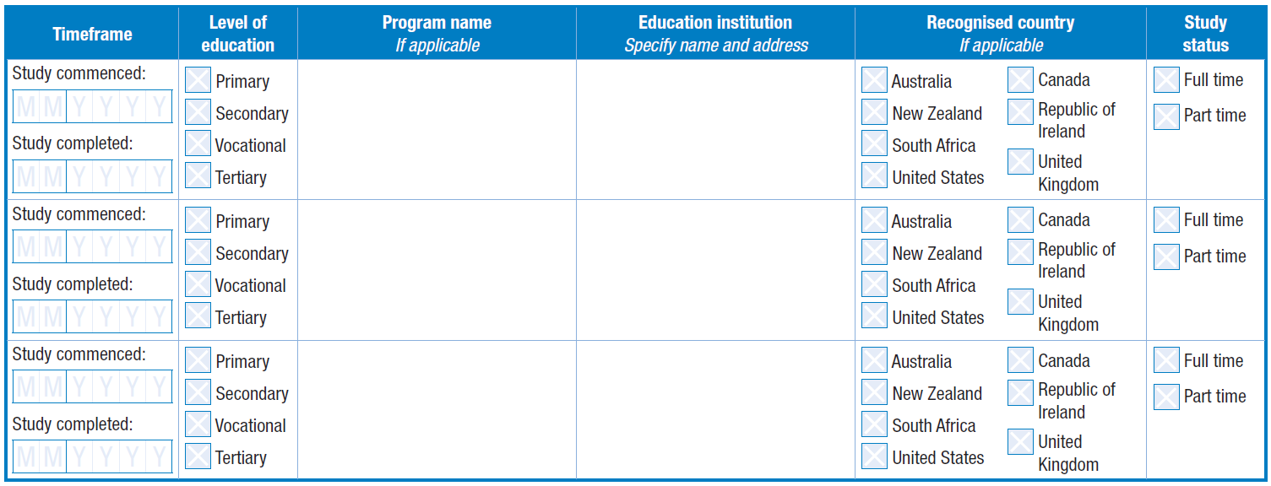

University of Canberra,

Bruce, ACT

Bachelor of Physiotherapy

Higher School Certificate

12 2013

01 2010

12 2009

01 2008

Belconnen High School,

Hawker, ACT

##### Primary language pathway



06 2014

09 2009

12 2006

01 2001

12 2000

01 1995

Bachelor of Dental Medicine

University of Geneva, Geneva, Switzerland

Melbourne Girls College, Richmond, Victoria

Box Hill North Primary School, Box Hill, Victoria

##### Extended education pathway



Boston University, Boston Massachusetts USA

06 2012

Master of Science (Occupational therapy)

09 2010

University of Colorado

Bachelor of Science (Pre-health)

06 2010

09 2006

1. Under section 38(1)(d) of the Health Practitioner Regulation National Law